DCN LAB

Lab Report No 10



# Spring 2025

# Submitted by: Naveed Ahmad

Registration No: **22pwsce2165**

class Section: B

“On my honor, as student of University of Engineering and Technology, I have neither given nor received unauthorized assistance on this academic work.”

Student Signature: ______________

Submitted to:

# Dr. Yasir Saleem Afridi

Month Day, Year (22 05, 2025)

Department of Computer Systems Engineering

University of Engineering and Technology, Peshawar

Lab 10

Introduction to Cisco Packet Tracer

## OBJECTIVES OF THE LAB

This lab aims to introduce Cisco Packet Tracer. Some specific topics covered in this lab are

* Creating Networks
* Making Connections
* Making LAN using Hub
* Making LAN using Switch
* Difference between hub and switch

## Introduction

Cisco Packet Tracer is an innovative network simulation and visualization tool. This free software helps you to practice your network configuration and troubleshooting skills via your desktop computer or an Android or iOS based mobile device. Packet Tracer is available for both the Linux and Windows desktop environments.

With Packet Tracer you can choose to build a network from scratch, use a pre-built sample network, or complete classroom lab assignments. Packet Tracer allows you to easily explore how data traverses your network. Packet Tracer provides an easy way to design and build networks of varying sizes without expensive lab equipment.

1. **Creating Devices**
   1. Choose a device type from the **Device-Type Selection** box
   2. Click on the desired device model from the **Device-Specific Selection** box
   3. Click on a location in the workspace to put your device in that location
   4. If you want to cancel your selection, press the **Cancel** icon for that device
   5. Alternatively, you can click and drag a device from the **Device-Specific Selection** box onto the workspace
   6. You can also click and drag a device directly from the **Device-Type Selection** box and a default device model will be chosen for you

1. **Making Connections**
   1. To make a connection between two devices, first click the **Connections** icon from the **Device-Type Selection** box to bring up the list of available connections.
   2. Then click the appropriate cable type.
   3. The mouse pointer will change into a "connection" cursor.
   4. Click on the first device and choose an appropriate interface to which to connect.
   5. Then click on the second device and do the same.
   6. A connection cable will appear between the two devices, along with link lights showing the link status on each end (for interfaces that have link lights).

1. **Creating Networks**

Packet Tracer is a cross-platform visual simulation tool designed by Cisco Systems that allows users to create network topologies and imitate modern computer networks. The software allows users to simulate the configuration of Cisco routers and switches using a simulated command line interface.

1. **Make a LAN using HUB in Cisco Packet Tracer.**

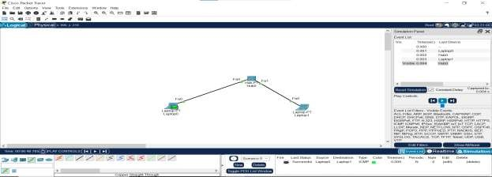

1. **Make LAN using SWITCH in Cisco Packet Tracer.**

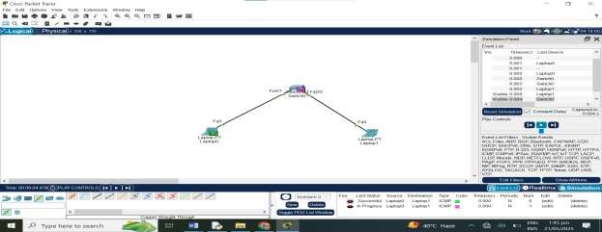

1. **What are the pros and cons of HUB?**

**Answer:**

**Pros of HUB:**

* 1. **Simple to use** – Easy to set up and use.
  2. **Cheap** – Less expensive than switches or routers.
  3. **Broadcasts data** – Sends data to all devices, making it simple.

**Cons of HUB:**

* 1. **Slow speed** – Can cause network to slow down.
  2. **No security** – Data is sent to all devices, not just the one it's meant for.
  3. **No smart decisions** – Can’t manage traffic like a switch can.

* 1. **What are the pros and cons of SWITCH?**

**Answer:**

**Pros of SWITCH:**

* 1. **Faster** – Sends data only to the correct device.
  2. **Secure** – Data is not shared with all devices. 3. **Efficient** – Handles traffic better than a hub.

**Cons of SWITCH:**

* 1. **Costly** – More expensive than a hub.
  2. **Setup** – Slightly more complex to set up.
  3. **No internet sharing** – Can’t connect directly to the internet like a router.

5. Which ethernet cable did you use for the connection between HUB and PC?

**Answer:**

**Straight-Through**

**5. What does a switch store in its memory?**

**Answer:**

A **switch stores a MAC address table** (also called a CAM table) in its memory.

This table maps:

* **MAC addresses** of devices
* To their **connected ports**

This helps the switch send data to the correct device only.